**MS WORD**

* Introduction
* Views
* Working with Files
* Working with Text
* Formatting Text
* Lists
* Columns
* Graphics
* Print Documents
* Paragraph Formatting
* Tables

**MS POWERPOINT**

* Introduction
* Create a new presentation
* PowerPoint screen
* Working with slides
* Add content
* Work with text
* Working with tables
* Graphics
* Save & Print
* Master slides
* Headers and Footers
* Slide animation
* Slide Transitions
* Adding Action Buttons
* Adding Sound to a Presentation

**MS EXCEL**

* Spreadsheet Basics
* Modifying Worksheets
* Formatting Cells
* Formulas and Functions
* Sorting
* Page Properties and Printing
* Charts

**What is Microsoft Word?**

* A word processing program that allows the user to format text with attributes such as bold, italics, font size, and margins.

**Getting Started**

All computers are different, but to start MS Word, you will probably have to do something along these lines.

* Click on **Start Uploaded Image: arrow.pngAll Programs Uploaded Image: arrow.pngMicrosoft Office Word 2007**   
      *or*
* Click on **Start Uploaded Image: arrow.pngAll Programs Uploaded Image: arrow.pngMicrosoft Office Uploaded Image: arrow.pngMicrosoft Office Word 2007**

**Getting Around in Word**

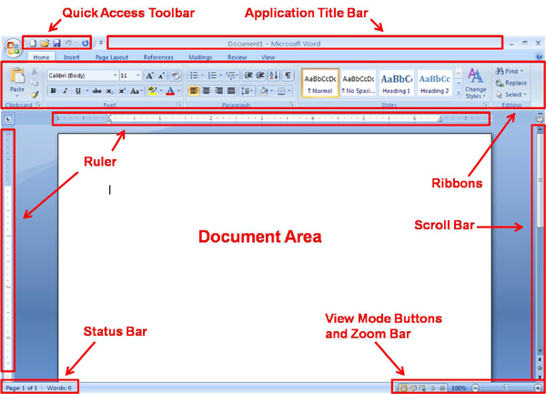

**Application Title Bar**  
This is the blue bar at the top of the Word application environment. Almost all Windows applications have a title bar. It displays the title of the application and often the name of the file that you opened, such as *ENGL1102 crazy book report thing.doc - Microsoft Word*.  
  
**Ribbons**  
Located just beneath the title bar, the Ribbons are where most of the functionality in Word is organized and accessed. There are seven basic Ribbons, and more appear when you select unique objects such as pictures. Click through each ribbon to familiarize yourself with the locations of Word's various functions.  
  
**Quick Access Toolbar**  
The Quick Access Toolbar is a short row of icons on the left side of the Application Title Bar. It allows quick access of basic document functionality such as New, Open and Save. You can click on the Office Button on the far left to access a pull-down menu with a more complete and descriptive list of functions.  
  
**Status Bar**  
Located at the bottom of the Word application window, the Status Bar is generally used to show your location within a document as well as the current word count.  
  
**Ruler**  
The top ruler appears when you're in the default Print Layout view, the Web Layout view and the Draft view (explained later). The side ruler appears only in the Print Layout view.  
  
**View Mode Buttons**  
Located at the lower right of the active document window, they allow the document to be viewed in five different ways. We will discuss these different views in detail later.   
  
**Zoom Bar**  
Located to the right of the View Mode Buttons, they allow you to zoom in and out of the document. It's pretty self-explanatory.  
  
**Scroll Bars**  
These are located to the right and bottom of the document window. You probably already know how to use them.  
  
**Document Area**  
The main area of Word where text is composed. This also includes the Ruler, Scroll Bars, Status Bar, View Mode Buttons and Zoom Bar.

**Using Word**

Word is a WYSIWYG (pronounced *wiz****'*** *• ee • wig'*) program, which stands for "What You See Is What You Get." That means that the style of the text you see on the screen is what you see when you print the document. It wasn't always like that. Many, many years ago when dot-matrix printers roamed the earth, text always printed with the same font.   
  
We will only discuss some of the most common and useful features of Word in this lab. For more help, browse through the menus and consult the online help manual. You can also hit F1 anytime for even more help.

**Views**

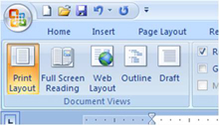  
  
You can look at your document in various ways in Word. Some views will show the formatting options applied while others will show you what your document will look like if you print it. You can access these different views in the **Document Views** section of the **View** ribbon. Some of the different views are as follows:

**Draft view**  
Shows a white work area with text and graphics. This view is *not* completely WYSIWYG, so you will not see columns or headers and footers, etc. Instead, you will be able to see page breaks and section breaks (more detail about those features later).   
  
**Outline view**  
In outline view, Word simplifies the text formatting to help you focus on the structure of your document. Each heading level is formatted with the appropriate built-in heading style (Heading 1 through Heading 9) or outline level (Level 1 through Level 9). Paragraph formatting doesn't appear. Also, the ruler and the paragraph formatting commands are not available.   
  
**Print Layout view**  
Displays a document as text on a piece of paper. The display is very close to the way the document will look when printed. Print Layout View is used for precise placement and sizing of objects within a document. On recent versions of Word, this display mode is selected by default.  
  
**Web Layout view**  
This shows your document the way it would appear if you were to save it as an HTML document.  
  
**Full Screen Reading view**  
This shows your document in a *possibly* easier to read format by splitting your text into smaller pages. Separate pages in this view do not necessarily correspond to page separation in your actual document.

**Text formatting**

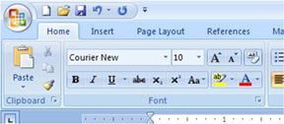

**Fonts and Sizes**  
The list of fonts is in a drop-down menu in the **Font** section of the **Home** ribbon. If you press the arrow on the drop-down menu, you can scroll up and down in the list and choose a new font. You will be using the new font when you start typing.   
  
How to change existing text from one font to another:

1. Highlight the text (move your cursor to just before the first character you want, click down, and drag the cursor to include the last character you want, then let go of the mouse button. Your selection should be now be displayed in a different color).
2. Go to the font drop-down menu and choose a different font.
3. The list of font sizes is right beside the list of fonts. Differently sized fonts are often used for headings or titles to make them stand out. You change font sizes the same way that you change fonts.

**Style**  
There are various ways to make your words stand out more, such as bold, italics, and underline. Their icons are also in the **Font** section of the **Home** ribbon, underneath the list of fonts. They look like B, I, and U, respectively. Click each option to turn it on, and then click again to turn it off. If you want to change existing text, highlight the text and click one of the buttons.

**Paragraph formatting**

Word defines a paragraph as text with a carriage return at the end of the line. These are some options you can apply to paragraphs.

**Alignment**  
  
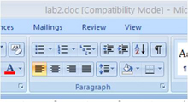  
  
You can make all the text line up on the left margin, right margin, both margins, or the center of the page. The buttons for Align Left, Center, Align Right, and Justify are in the **Paragraph** section of the **Home** ribbon.   
  
**Spacing**  
You can single-space, double-space, or set your own spacing for your paragraphs. Single-spacing leaves very little white space between two lines of text in a paragraph. Double spacing leaves one line of blank space between lines of text.  
  
How to change the line spacing from single to double:

1. Click the little arrow in the bottom right corner of the **Paragraph** section.  
     
   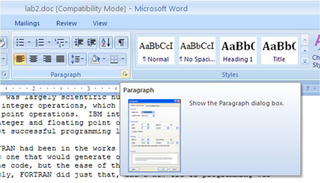
2. A dialog box will pop up that lists the sections.
3. Look under the **Spacing** header and look for the **Line Spacing:** header. Change the value in the drop-down box from "Single" to "Double".  
     
   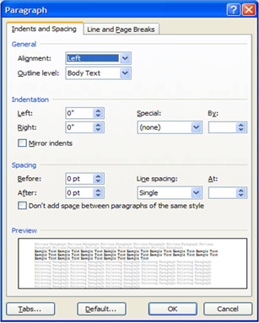

**Moving text**

If you want to move text from one part of your document to another, you can cut, copy, paste, or move text using the mouse.

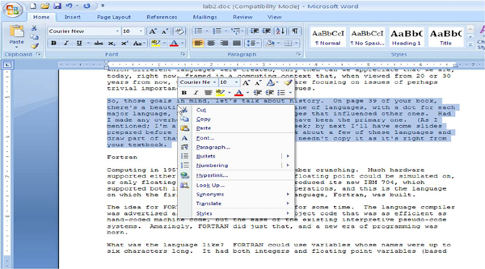

* To cut text, highlight the text, then right-click in the highlighted area and select Cut from the pop-up menu OR press **Ctrl** and **x**.
* To copy text, highlight the text, then right-click in the highlighted area and select Copy from the pop-up menu OR press **Ctrl** and **c**.
* To paste text, move the cursor to the desired location, then right-click on that location and select Paste from the pop-up menu OR pres **Ctrl** and **v**.
* To move text, use your mouse to highlight and drag the text around. When you have found the place you want to leave the text, let go of the mouse button.

**Headers, Footers, REMOVED Numbers and You**

A header is for text that must go in the top margin of every page of your document or section.   
  
A footer is for text that must go in the bottom margin of every page of your document or section.   
  
REMOVED numbers can be inserted anywhere in your document, but you need to put it in the header or footer if you want to put it on every page of your document or section.

How to create/edit a header and footer:

1. Look at the **Header & Footer** section of the **Insert** ribbon.
2. Click on Header or Footer (depending on which one you want) and select the Blank option from the pop-up menu.  
     
   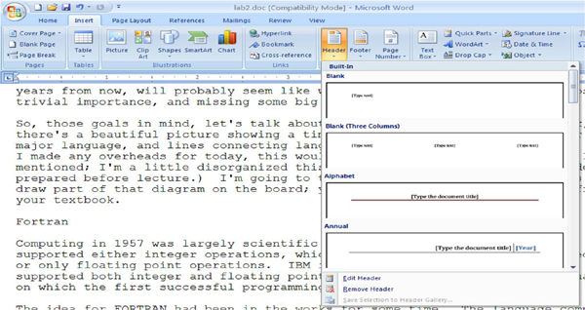
3. Word will now show you the new header or footer. Type the text you want. You can format it using bold, italic or underline options just like any other text. Note also the appearance of the new **Header & Footer Tools** ribbon.  
     
   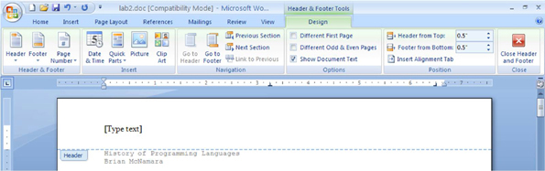
4. After you're done, switch to Print Layout view to see the new header and/or footer, which will appear in the top and bottom of each page as grey text. (It will still print in black.) To edit the header or footer, double-click on it on any page.

How to add page numbers:

1. Look at the **Header & Footer** section of the **Insert** ribbon.
2. Click on REMOVED Number and select from the pop-up menu where you want the page numbers to appear.  
     
   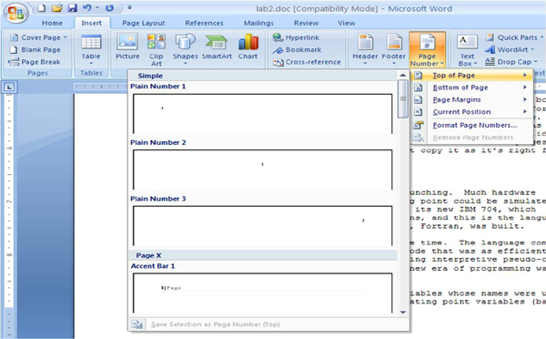
3. Continue from step 3 for adding headers and footers. Note that you can add text along with page numbers in the same header.

**Columns**

Word can make your text flow in newspaper-like columns. This feature is often useful for desktop publishing.

How to create columns:

1. Select the text that you want to flow in columns.
2. Select the Columns option in the **REMOVED Setup** section of the **REMOVED Layout** ribbon and choose the number of columns you want.  
     
   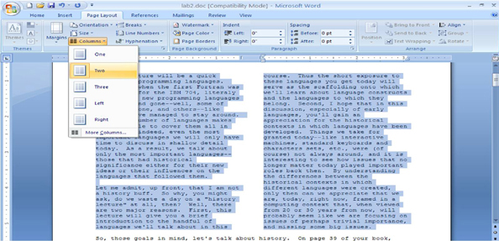

**Tables**

Columns are great for flowing text, but if you need to control the exact layout of data, you may want to use tables. The following is an example of a table; note that both graphics and text are in this table.

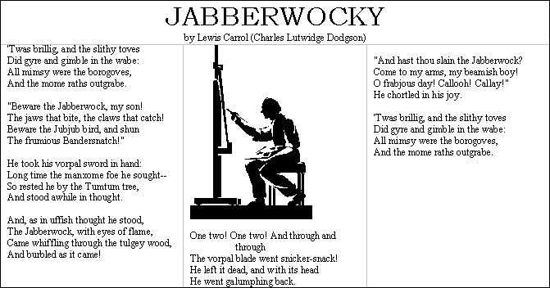

The fundamental element of a table is a rectangular area called a cell. Individual cells are referenced by the intersection of their column and row. The following is an example of a small table with cells labeled.

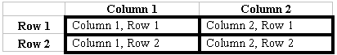

The most common use of tables is for displaying numbers, but each of the cells in the above table can contain text, a picture, an object, or any combination of the three.

How to create a table:

1. Click the Table option in the **Tables** section of the **Insert** ribbon.  
     
   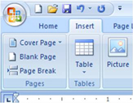
2. From the drop-down menu, you can insert a table in one of two ways: 1. Click on the square from the top left corner that represents the number of rows and columns you want. For instance, if you want a table that's five columns wide and three rows high, select the square that's five squares over and three down from the top left square. 2. Click on the Insert Table option in the drop-down menu and then, in the pop-up window, select the number of rows and columns you want.  
     
   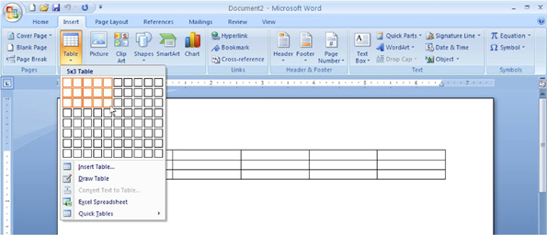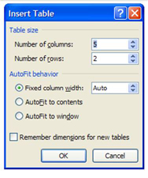
3. Click on the cell you wish to edit, and enter your data. Note the new **Table Tools** ribbons that appear.  
     
   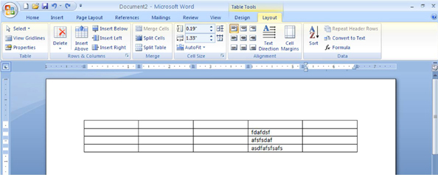
4. Repeat for each cell you want to edit.

Sometimes, you will need to add new columns or rows to a growing table or remove columns or rows that contain data you no longer need.  
  
How to add a row:

* To add a row to the bottom of the table, go to the bottom right cell and press tab.   
  *or*
* To add a row to the middle of a table, look in the **Rows & Columns** section of the **Layout** Table Tools ribbon. Click Insert Above to insert a row above the row with the cursor and Insert Below to insert a row below the row with the cursor.

Adding a column is done the same way as a row, except you'll select Insert Left or Insert Right instead.  
  
How to delete a row or column:

1. Place the cursor in a cell that's a member of the row or column you wish to kill.
2. Select Delete in the **Rows and Columns** section of the **Layout** Table Tools ribbon.  
     
   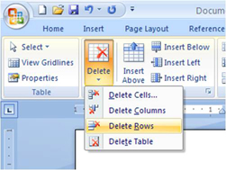
3. Select Delete Rows or Delete Columns from the drop-down menu.

**Text Boxes**

Like tables, text boxes can enhance the presentation of data. A text box is essentially a movable data holder. If you consider the whole document to be laid out on a piece of paper, a text box would be a separate sheet of paper placed on top of the main document and thereby movable within the main document. Formatted text, graphics, tables, or any other supported object can be placed within a text box. If you move the text box, the data inside moves too. Also note that when a text box is placed in the middle of a body of text, the text is shifted around the text box; this is a very powerful feature. Here is an example of text boxes in a Word document:

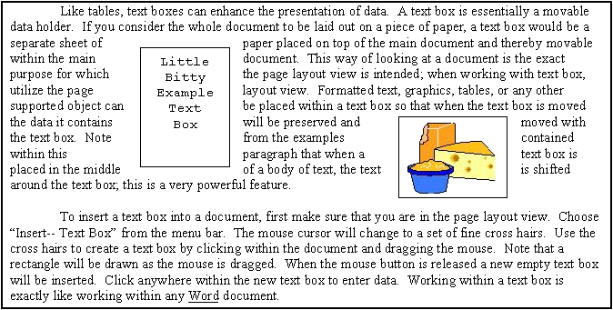

How to insert a text box:

1. Make sure that you are in Print Layout view.
2. Choose Text Box from the **Text** section of the **Insert** ribbon.
3. Choose Simple Text Box from the drop-down menu.  
     
   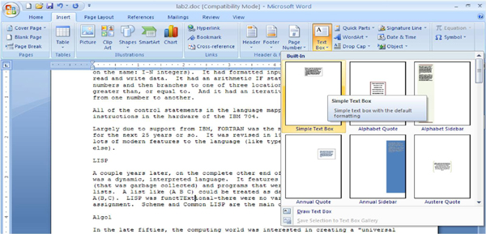
4. Type text into your textbox. You can also cut or copy text from your main document and paste it into the textbox.

Working within a text box is exactly like working within any Word document. You can format the text or insert graphics (as shown in the next part).

**Pretty Pretty Pictures**

In Word, you can insert graphics to make your document more interesting.

How to insert a picture:

1. Make sure that you are in Print Layout view.
2. Choose Picture from the **Illustrations** section of the **Insert** ribbon.  
     
   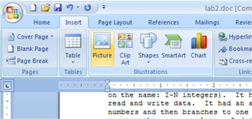
3. Use the file browser to find the picture you want to insert and then click the **Insert** button.

**Grammar Check & Spell Check**

Always proofread your documents before you release them to your audience!! Word's Spell Check and Grammar Check features are very useful for this purpose. Word can check your document as you type. Red wavy lines under your text denote possible spelling errors, and green wavy underlines denote possible grammar errors. Right click on the underlined words to see why Word thinks they are wrong.

How to spell check and grammar check your whole document:

1. Place your cursor at the beginning of your document.
2. Choose Spelling and Grammar in the **Proofreading** section of the **Review** ribbon.  
     
   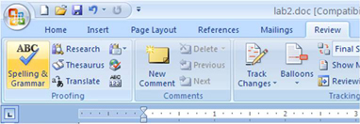
3. If Word thinks a word is questionable, you can make it ignore this instance of the word, ignore all instances of the word, add the word to the dictionary, take Word's suggestion, or fix it yourself.
4. If Word thinks a sentence is questionable, it will tell you why it thinks the sentence is grammatically incorrect and give you some suggested fixes. You can choose them or click directly on the text in your document to edit the sentence. Click the Resume button on the Spelling and Grammar dialog box when you are done correcting the sentence.

**Print Preview**

When you are done with your document and want to print, use the Print Preview feature to make sure things look right.

How to use print preview:

1. Click on the Office button in the top left corner of the screen.
2. Select **Print -> Print Preview** from the drop-down menu.  
     
   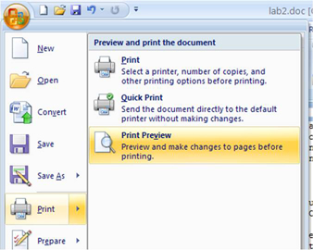
3. Scroll through the pages to make sure things look fine.